**Shopbridge online shopping app**

Dear,

This is a basic CURD operational functioning app, made through Python script using Django Framework and MySQL DB.

I Have Created a Product model with

* Product name
* Product Price
* Products Description
* Product Image name

As rest API are very quick and secure to build in Django, I have used REST FRAMEWORK Api to handle data requests. We can create an item with the above mentioned details, edit any thing from that list by passing data, we can get the specified data through the id or we can get the complete data in the model,

And finally we can delete the specified data or if we cant to clear all fields we can delete all of them.

To start the project we can clone or download the zip file from **GIT**

**To clone :** [**https://github.com/nrajesh593/shopBridge.git**](https://github.com/nrajesh593/shopBridge.git)

Following the guide/Steps involved to make the setup to test the code. its simple and easy

1. For development we can create a virtual environment in our directory and type below

***->python -m venv venv***

***-> cd venv/scripts***

***-> activate***

***-> cd ../..***

***-> pip install Django***

***-> pip install djangoframework***

1. Since we are using database as MySQL we need to install python package to connect to MySQL(default in Django we can use sqlite)

***->pip install mysqlclient***

1. Creating a django project (here I’m using project name as shopBridge)

***->django-admin startproject shopBridge***

1. Creating a app to make modules independent(here im creating app name as products)

***-> cd shopBridge***

***->django startapp products***

1. First we need to make SQL connections with our project. To do this edit settings.py page in shopBridge folder and replace DATABASE variable with

*DATABASES = {*

*'default': {*

*'ENGINE': 'django.db.backends.mysql',*

*'NAME': '<shopBridge>, #database name*

*'USER': root, #database username*

*'PASSWORD': ‘’, #database password*

*'HOST':’localhost’, #database host or ip address*

*'PORT': '3306',*

*'OPTIONS': {*

*'init_command': "SET sql_mode='STRICT_TRANS_TABLES'"*

*}*

*}*

*}*

1. In the last line we use SET **sql_mode = 'STATIC_TRANS_TABLES'** which is used to handle the invalid or missing values from being stored in the database by INSERT and UPDATE statements.
2. We need to migrate our applications to database. To do this

***-> python manage.py makemigrations***

***->python manage.py migrate***

Note: Run the above commands if we change anything in the models

1. After successful migration we can runserver and check if it connected and running fine

***-> python manage.py runserver***

1. We can check the result in http:www.localhost:8000/ (default)
2. If we want to add items in database send JSON data in following URL with **POST** call.

The below requests are made through post man API

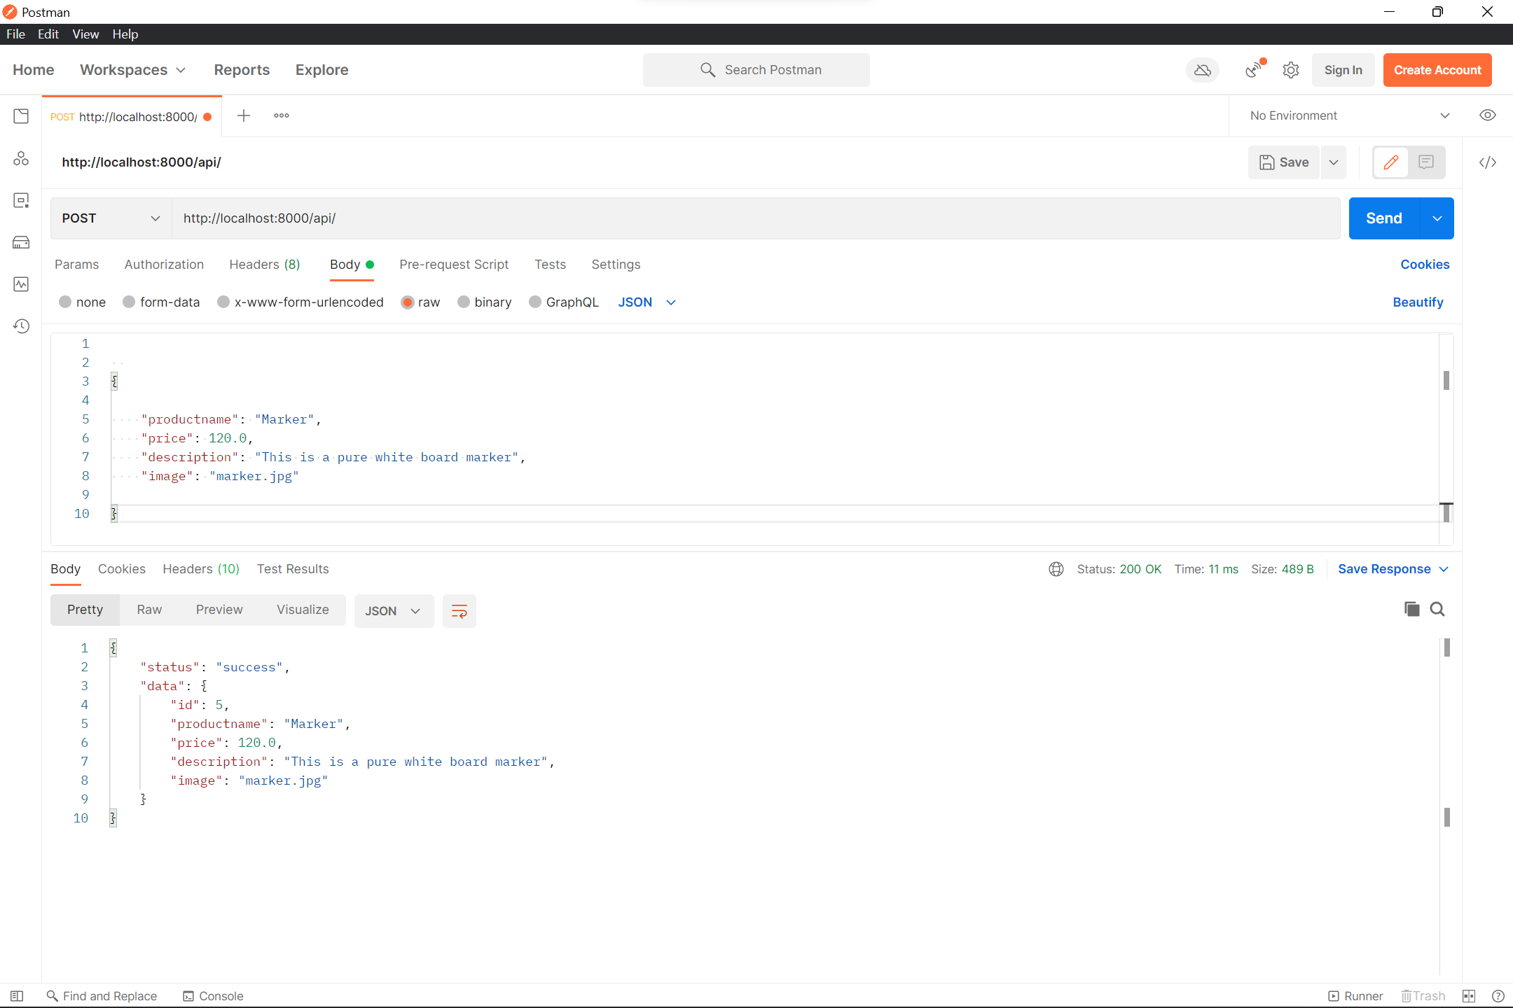

<http://localhost:8000/api/>

* **Request**

{

"productname": "Pen",

"price": 100.0,

"description": "Pen make to write smoothly",

"image": "pen.jpg"

}

* **Response**

{

"status": "success",

"data": {

"id": 1,

"productname": "Pen",

"price": 100.0,

"description": " Pen make to write smoothly ",

"image": "pen.jpg"

}

}

1. If we want to get/retrieve the data , we can either get all the data or else we can get and individual data by passing id in the api/url with **GET** type

* if nothing is passed we will get all the data fields

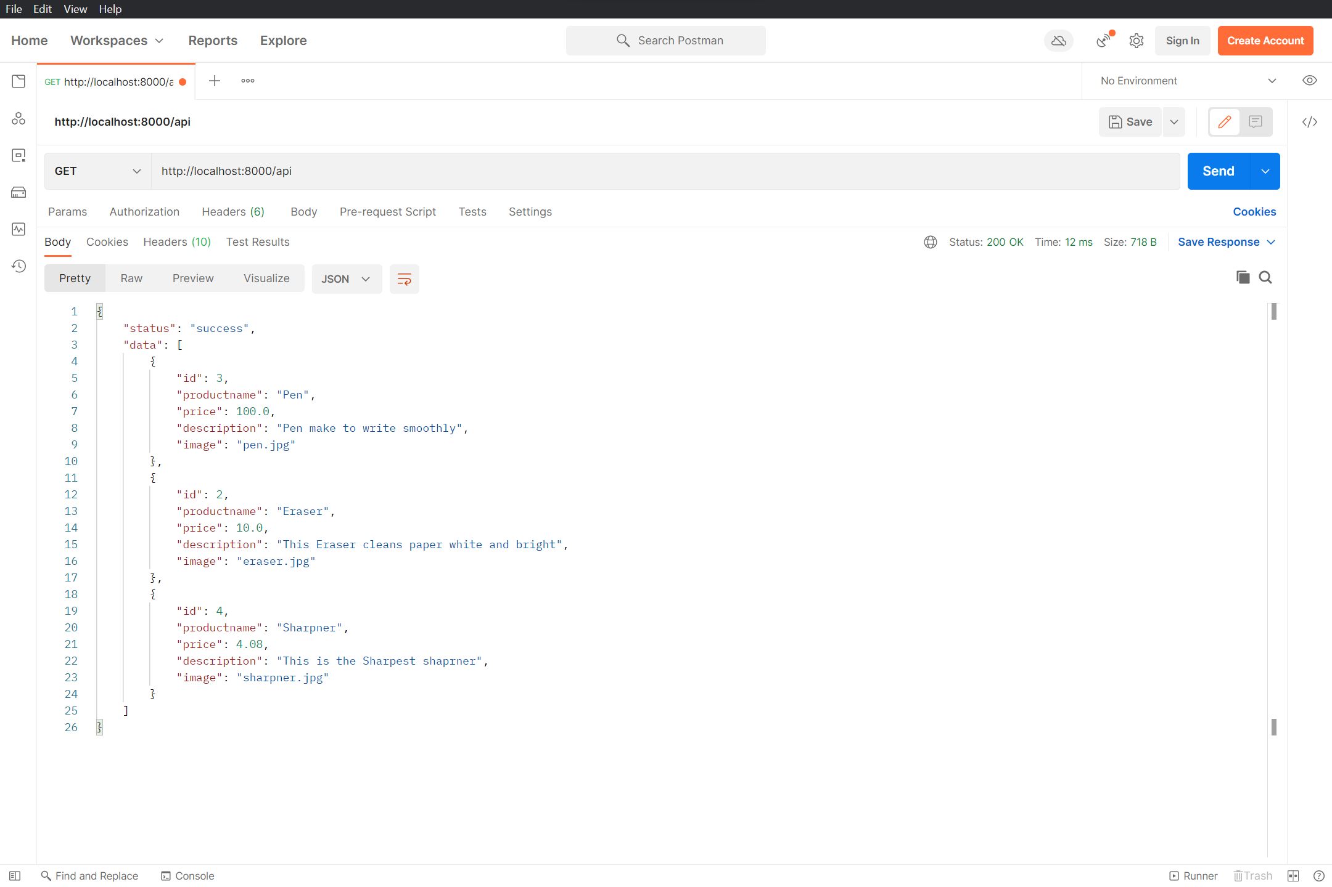

* if we pass id along with url only the specified will appear

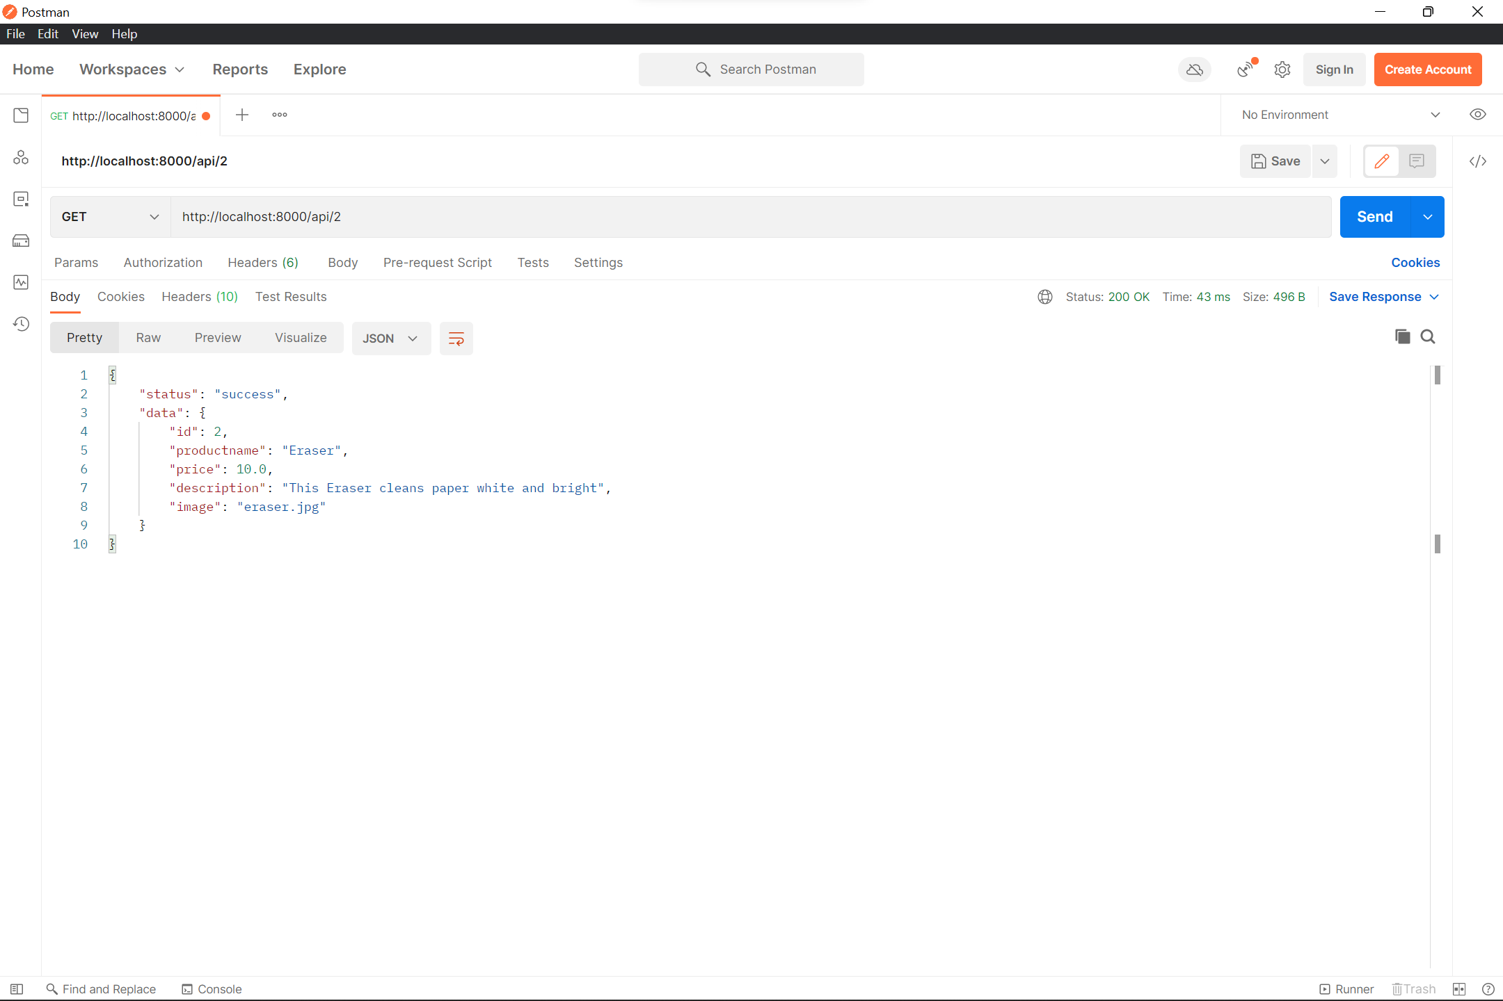

1. To edit the data we must pass the id with required fields to be edited example we wi want to edit price of product_id 3

We need pass the same URL with **PATCH**  type

<http://localhost:8000/api/3>

{

"id": 3,

"productname": "Pen",

"price": 137.2,

"description": "Pen make to write smoothly",

"image": "pen.jpg"

}

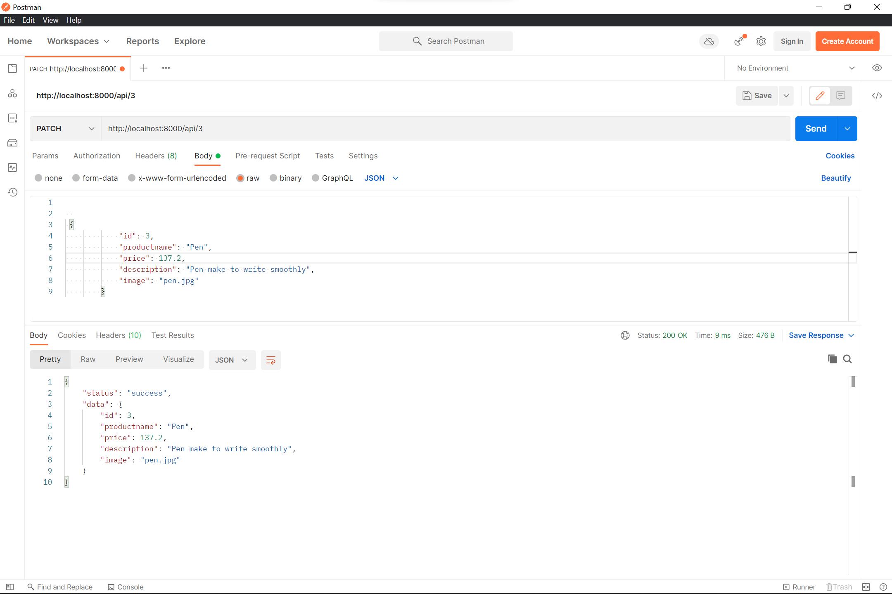

1. To delete the selected item we can pass **DELETE**  type from the API

* if we pass id, only the specified id object will be deleted

<http://localhost:8000/api/3>

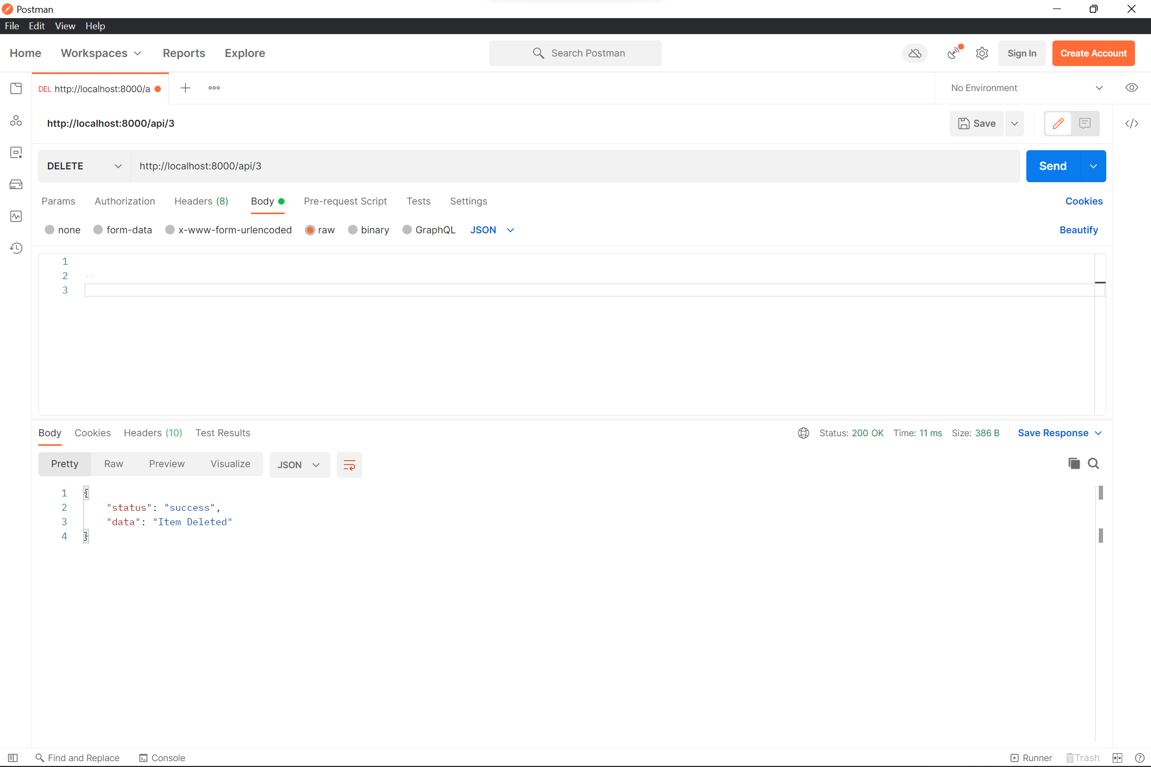

* if we want to delete all the items at once we call the URL without any ID

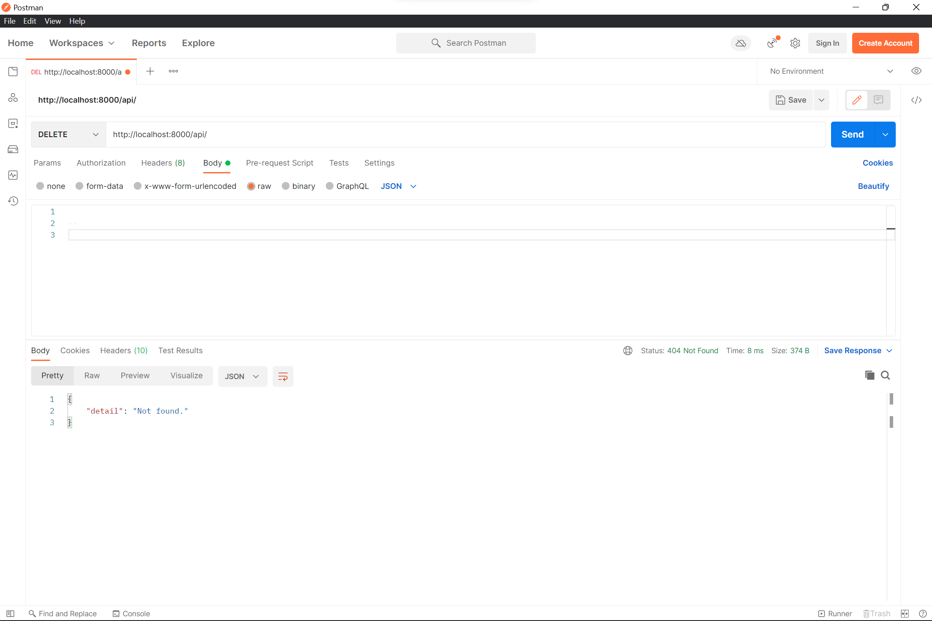

Thanks for giving me this opportunity to prove myself eligible for getting hired in your company.

Regards

N Rajesh